Chapter 10

Exercise Solutions

Ex 10.1
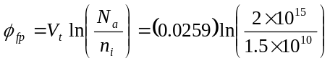
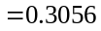V
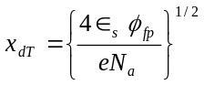
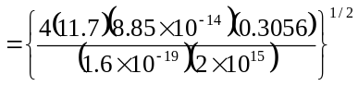
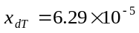cm
or 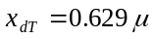m
_______________________________________

Ex 10.2
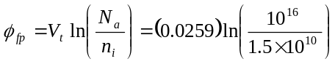
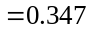V
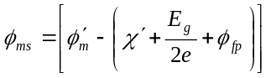
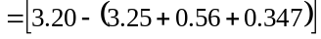
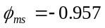V
_______________________________________

Ex 10.3
From Figure 10.16, 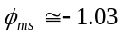V
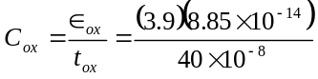
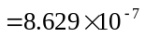F/cm
Then
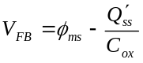
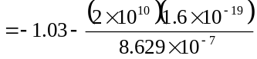
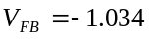V
_______________________________________

Ex 10.4
From Figure 10.16, 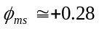V
We find
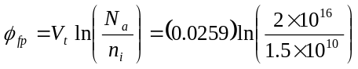
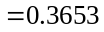V
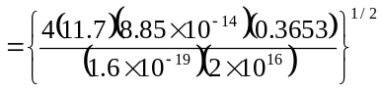
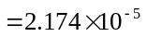cm
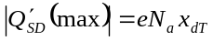
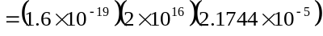
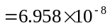C/cm
Then
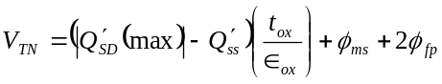
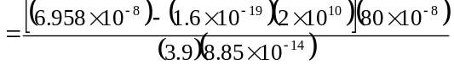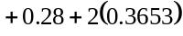
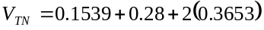
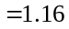V
_______________________________________

Ex 10.5
From Figure 10.16, 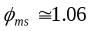V
We find
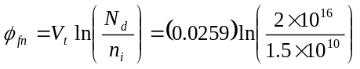
V
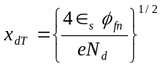
cm

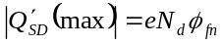
C/cm
Now
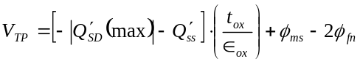
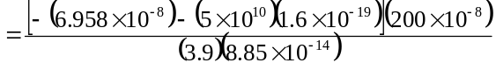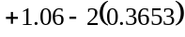
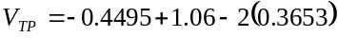
or 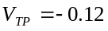V
_______________________________________

Ex 10.6
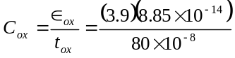
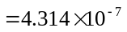F/cm
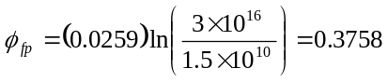V
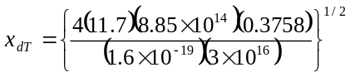
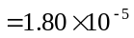cm
Now
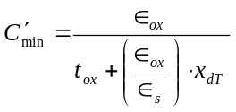
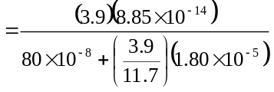
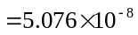F/cm
We find
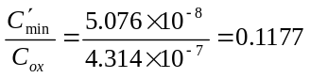
Now
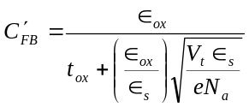
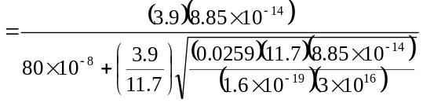 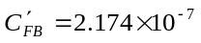F/cm

We find
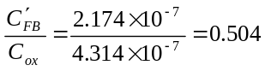
_______________________________________

Ex 10.7
We find
F/cm
Then
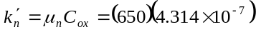
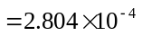A/V
or 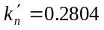mA/V
Now
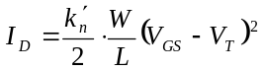
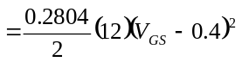
- 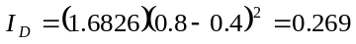mA
- 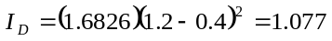mA
- 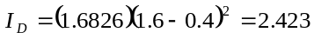mA
_______________________________________

Ex 10.8
We find
F/cm
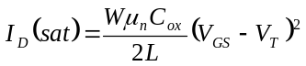
Then
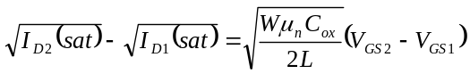
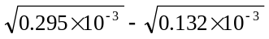
Then
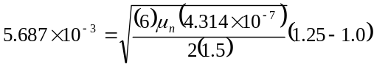
Or
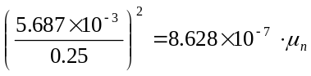
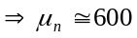cm/V-s

We now find
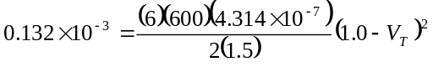
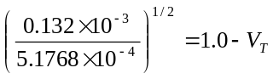
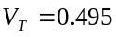V
_______________________________________

Ex 10.9
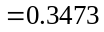V
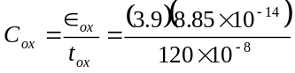
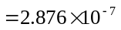F/cm
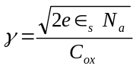
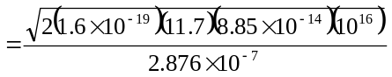
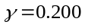V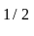
- 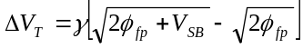
(i)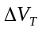
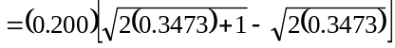
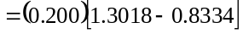
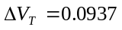V
(ii)
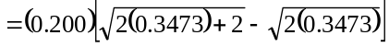
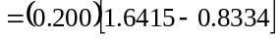
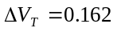V
_______________________________________

Ex 10.10
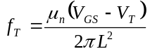
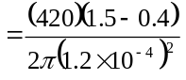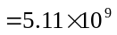Hz
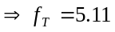GHz
_______________________________________

Test Your Understanding Solutions

TYU 10.1
- 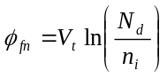
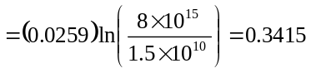V
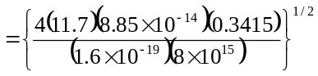
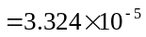cm
or 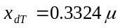m
- 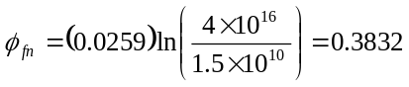V
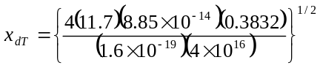
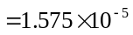cm
or 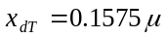m
_______________________________________

TYU 10.2
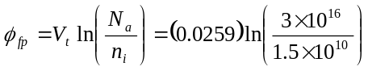
or
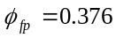V
We have
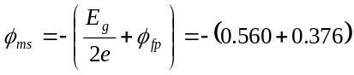
or
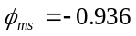V
_______________________________________

TYU 10.3
From TYU 10.2,
V
We have
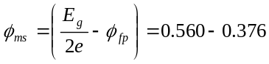
or
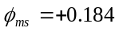V
_______________________________________

TYU10.4
V
From Equation (10.17)
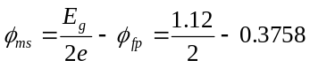
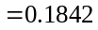V
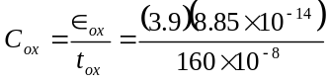
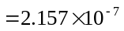F/cm

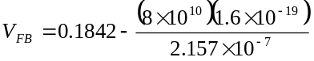
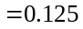V
_______________________________________

TYU 10.5
V
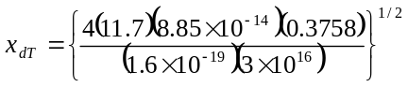
cm
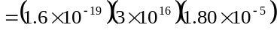
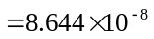C/cm
From Figure 10.16, 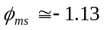V
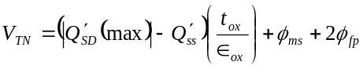
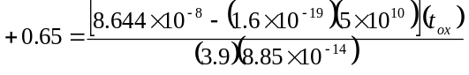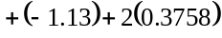
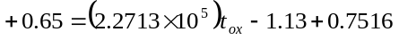
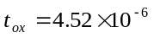cm
or 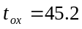nm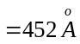
_______________________________________

TYU 10.6
From Ex 10.7, mA/V
Then
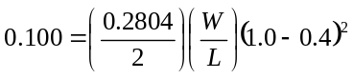
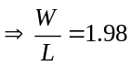
_______________________________________

TYU 10.7
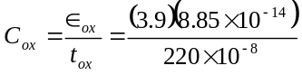
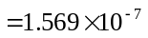F/cm
Now
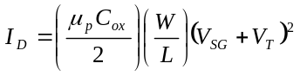
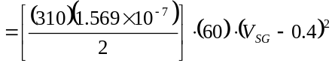
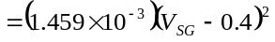 A
Then
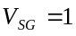V 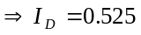mA
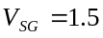V 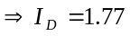mA
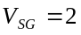V 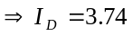mA
_______________________________________

TYU 10.8
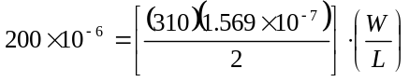
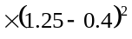
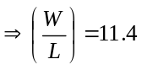
_______________________________________

TYU 10.9
F/cm
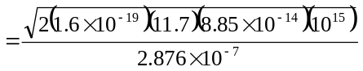
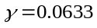V
- 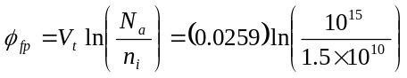 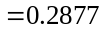V
(i)
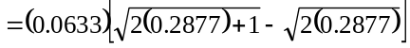
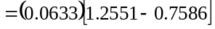
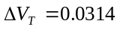V
(ii)
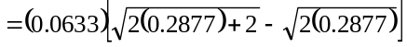
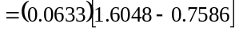
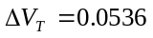V
_______________________________________

TYU 10.10
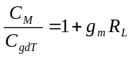
We find
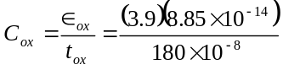
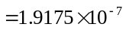F/cm
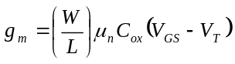
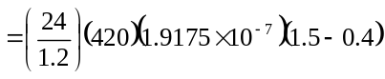
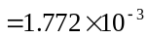A/V
Then



